MEMORANDUM

DEPARTMENT OF TRANSPORTATION
Project Development Branch

4201 East Arkansas Avenue
Denver, Colorado 80222
(303)757-9040
FAX (303)757-9868
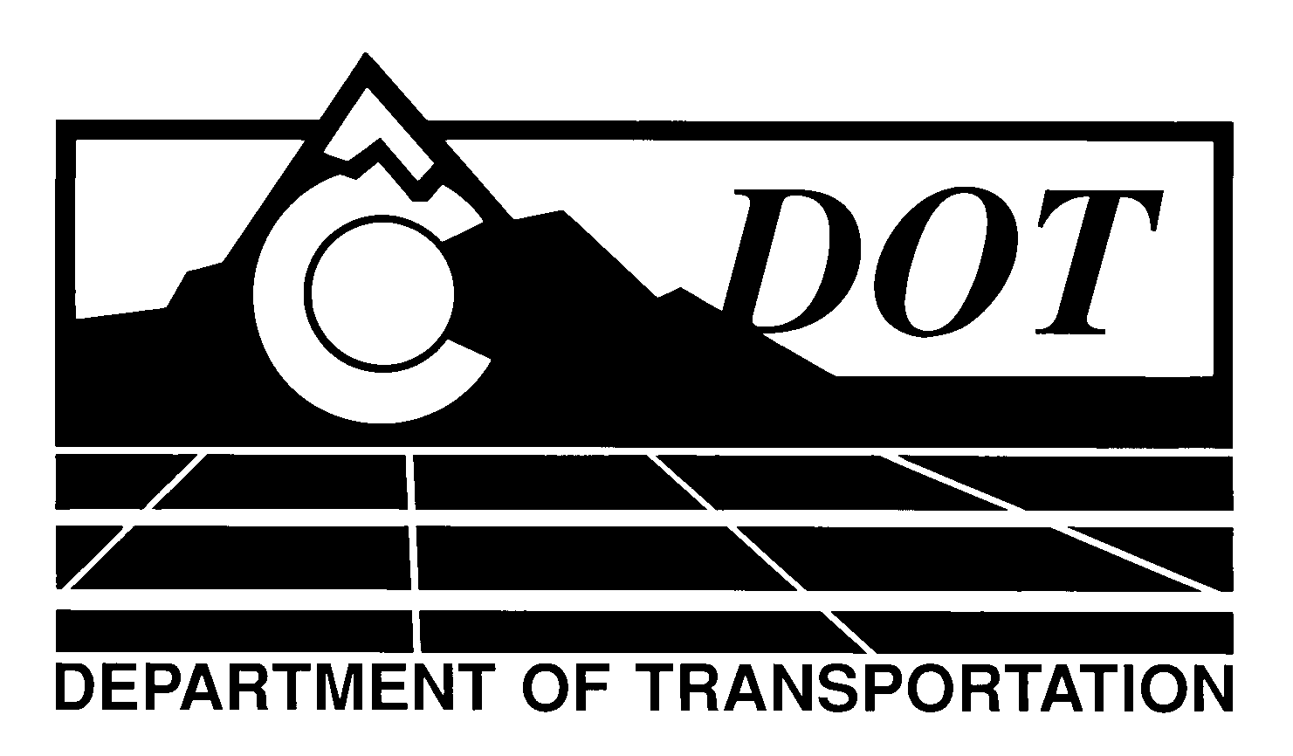

DATE: May 5, 2011

TO: All Holders of Standard Special Provisions

FROM: Larry Brinck, Standards and Specifications Engineer

SUBJECT: Revision of Section 109, Compensation for Compensable Delays

Effective this date, our unit is issuing a new standard special provision, Revision of Section 109, Compensation for Compensable Delays. This new standard special is 1 page long. Use this standard special in all projects, beginning with projects advertised on or after June 2, 2011. Please feel free, however, to include it projects advertised before this date.

This new standard special provision clarifies what costs can be compensated in a compensable delay.

Those of you who keep books of Standard Special Provisions should add this new standard special provision to your file. We are attaching a new Index of Standard Special Provisions, dated this same date, for your convenience. In addition, you will find this and other special provisions that are being issued this date in one place in the CDOT Construction Specifications web site:

http://www.coloradodot.info/business/designsupport/construction-specifications/2011-Specs/recently-issued-special-provisions

If you have any questions or comments, please contact this office.

LB/mrs

Attachments

Distribution: Per distribution list

